1. Install latest Java jdk (you need this to do development in java.) In google, search for java jdk and install the one for your machine i.e. windows. Install the 32-bit/ 64-bit version according to your pc – it won’t let you install the wrong one – so try the other one if the first one you try does not work. Below screenshot shows the 32-bit version for Windows (64-bit one is below it:)

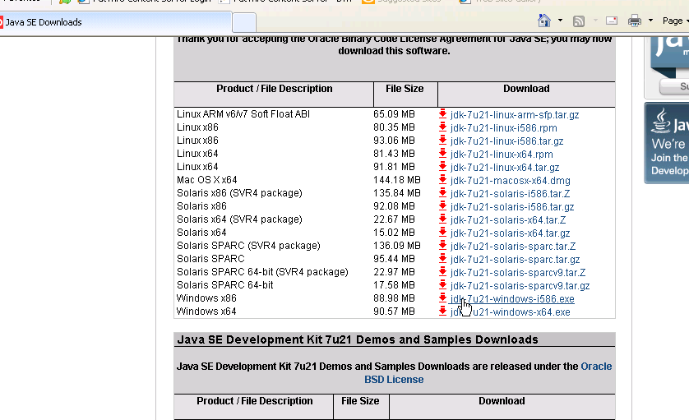

1. Install Intellij ([www.jetbrains.com/idea/download](http://www.jetbrains.com/idea/download)).
2. Install Maven Goto : <http://maven.apache.org/download.cgi> and install latest Binary zip from the ‘Link’ column Example: Maven 3.1.0 (Binary zip)
3. Unzip it and add the environment variable **MAVEN_HOME** with the location of folder containing the contents of the zip file. [how to add environment variables - <http://www.computerhope.com/issues/ch000549.htm>]
4. Make a duplicate environment variable **M2_HOME** with the same folder location (needed because intellij looks for **M2_HOME** instead of correct **MAVEN_HOME**)
5. Edit environment variable **PATH** and append ;%MAVEN_HOME%/bin to list (ensure you have the delimiting semi colon)
6. Also, ensure **JAVA_HOME** environment variable is present, if not add one with the value of *JDK_Location/bin
7. Test your Maven configuration by opening a command prompt and running "mvn -version" which should return the Maven version as well as the Java and OS details.
8. Take full svn update of C:\Projects
9. Open up a command prompt. Click “Start” then “Run” and type “cmd” and press ENTER. Type “c:” and press enter to get to c drive.

Now type “cd C:\Projects\testSeleniumFramework” and press enter to get to the project directory.

Now type “mvn clean install”

Should install the project and download all required resources successfully:

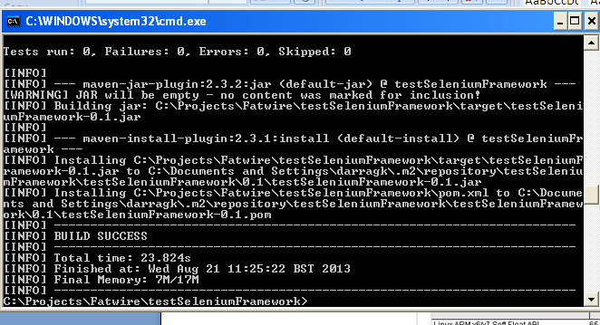

1. Now open up intellij. Click to import a project:

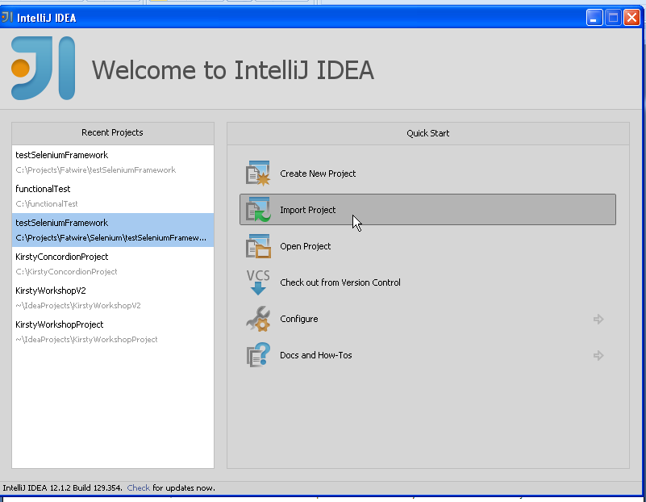

Select the pom file in the project:

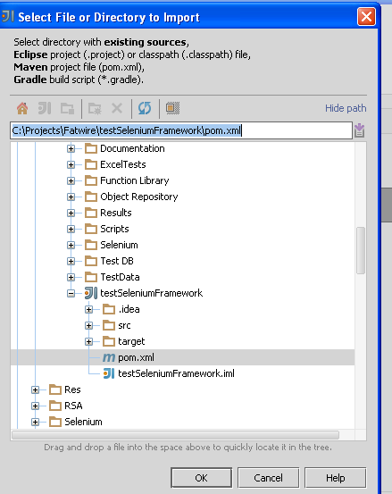

Click OK. Go through the process accepting all the defaults. When prompted for profiles select main:

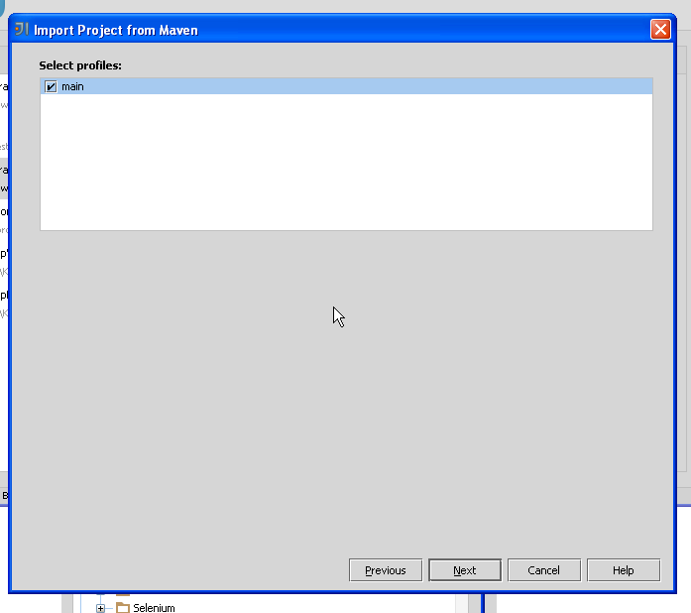

Complete the import process.

You will get a message about language and re-loading. Choose to reload the project.

Now set up the main source folder.

Click File>Project Structure

Select Module from the left hand side.

In the right hand side select the src/main folder and click on “Sources”:

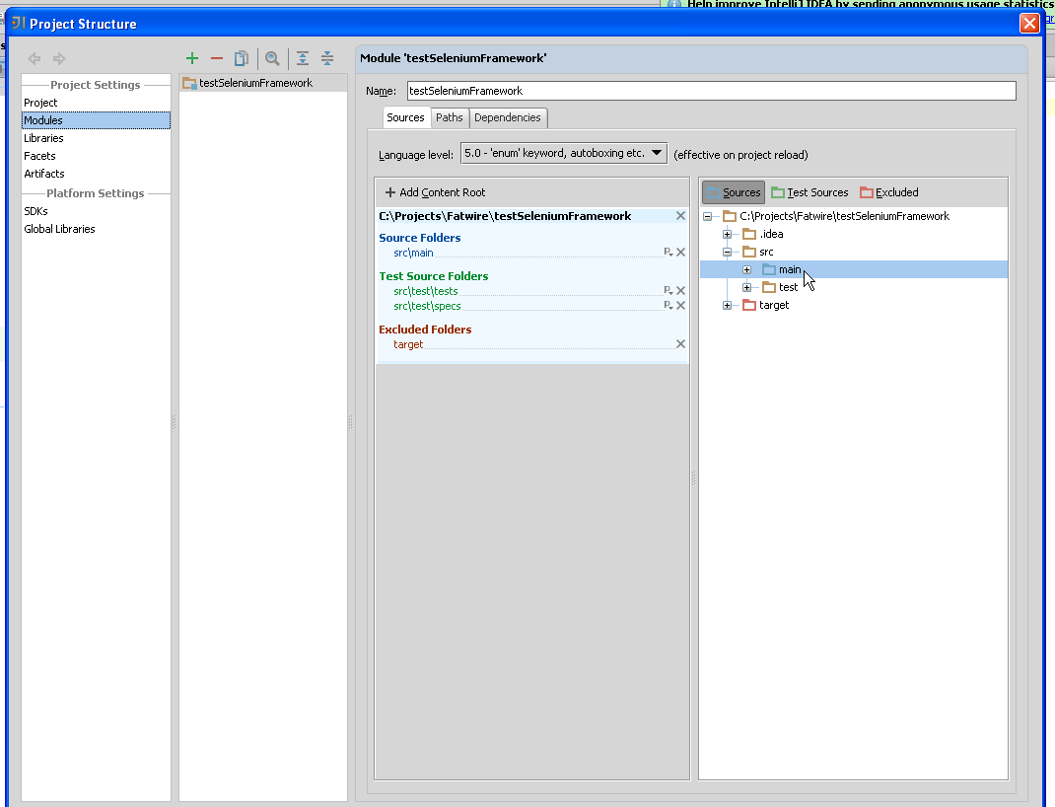

Click Apply.

You now should have your project set up and ready to use. You can add new tests.

Please note the only thing you should be committing to svn is stuff in the src folder:

To ensure Internet Explorer Driver works properly.

Open up Internet Explorer, go to Tools>Internet Options

Choose the Security tab:  
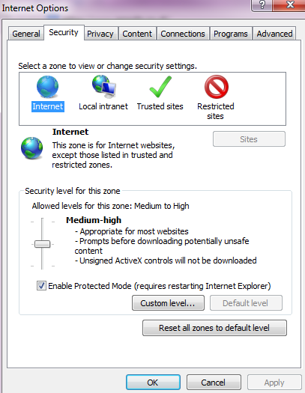

Make sure that for all sites (i.e. Internet, Local Intranet etc) that the Enable Protected Mode setting is either selected for all sites, OR not selected for all sites. Otherwise IE selenium webdriver won’t load.